Annex 4. Infection Control

Person responsible: HAI Prevention Coordinator
Back up: Medical Epidemiology

Rationale:

The primary strategies for preventing pandemic influenza are the same as those for seasonal influenza: vaccination, early detection and treatment with antiviral medications, and infection control measures to prevent transmission during patient care. However, when a pandemic begins, the ability to limit transmission in healthcare settings will rely heavily on the appropriate and thorough application of infection control measures. Infection control guidance is based on knowledge of routes of influenza transmission, the pathogenesis of influenza, and the effects of influenza control measures used during past pandemics and interpandemic periods.

Assumptions:

- Vaccines will not be available for up to 6 months from the onset of a pandemic.
- Once available, vaccines may be in short supply.
- Patients will seek medical care at both primary care providers and hospitals. Hospitals will exceed capacity quickly.
- Surgical masks and N95 respirators may be in short supply.
- Hospital staff will be reduced because of illness.
- Antivirals may not be sufficiently available or effective preventatively.
- An informed and responsive public is essential to minimizing the health effects of a pandemic and the resulting consequences to society.
- Attempts to reduce person-to-person viral transmission will prevent or delay influenza outbreaks.

Overview:

This Annex provides guidance to healthcare and public health partners on basic principles of infection control for limiting the spread of pandemic influenza. These principles (summarized in Box 1) are common to the prevention of other infectious agents spread by respiratory droplets. This Annex also includes guidance on the selection and use of personal protective equipment (PPE); hand hygiene and safe work practices; cleaning and disinfection of environmental surfaces; handling of laboratory specimens; post-mortem care, the management of infectious patients, the protection of persons at high-risk for severe influenza or its complications, and issues concerning occupational health.
This Annex contains infection control practices for a variety of healthcare settings, including hospitals, nursing homes and other long-term care facilities, pre-hospital care (emergency medical services [EMS]), medical offices and other ambulatory care settings, and home healthcare, as well as schools, workplaces, and community settings. The recommendations for infection control described below are generally applicable throughout the different pandemic phases.
Most information on the modes of influenza transmission is largely obtained through observations during outbreaks, and the amount of direct scientific information is very limited. However, the epidemiologic pattern observed is generally consistent with spread through close contact (i.e., exposure to large respiratory droplets, direct contact, or near-range exposure to aerosols).
Droplet transmission involves contact of the conjunctivae or the mucous membranes of the nose or mouth of a susceptible person with large-particle droplets containing microorganisms generated from a person who has a clinical disease or who is a carrier of the microorganism while coughing, sneezing, or talking and during the performance of certain procedures such as suctioning and bronchoscopy. Transmission via large-particle droplets requires close contact between source and recipient persons (about 3 feet). Special air handling and ventilation are not required to prevent droplet transmission.
Direct-contact transmission involves skin-to-skin contact and physical transfer of microorganisms to a susceptible host from an infected or colonized person, such as occurs when personnel turn patients, bathe patients, or perform other patient-care activities that require physical contact. Indirect-contact transmission involves contact of a susceptible host with a contaminated intermediate object, usually inanimate, in the patient's environment.
Airborne transmission occurs by dissemination of either airborne droplet nuclei or small particles in the respirable size range containing the infectious agent. Microorganisms carried in this manner may be dispersed over long distances by air currents and may be inhaled by susceptible individuals who have not had face-to-face contact with (or been in the same room with) the infectious individual. Preventing the spread of agents that are transmitted by the airborne route requires the use of special air handling and ventilation systems (e.g., negative pressure rooms). Transmission of influenza may occur at shorter distances through inhalation of small-particle aerosols (droplet nuclei), particularly in shared air spaces with poor air circulation. Additional precautions for healthcare personnel who perform aerosol-generating procedures (e.g., endotracheal intubation, suctioning, nebulizer treatment, bronchoscopy) on influenza patients may be warranted.
The recommendations for infection control described below are generally applicable throughout the different pandemic phases (inter-pandemic, pandemic alert, pandemic, and post-pandemic recovery). In some cases, recommendations may be modified as the situation progresses from limited to widespread community illness.

Pandemic Influenza Infection Control Strategies
By Severity and Transmissibility

 | HTH Transmissibility (Illness Rate in the Pop)
 | Low  Rare | Medium  5-20% | High  20-40%
 | Pandemic Severity Index (Case Fatality Ratio)
Interventions by Setting | 1  Low  <0.1 CFR | 2 and 3  Medium  0.1 - <1.0 CFR | 4 and 5  High  1.0- = >2.0 CFR
Hospitals:  Detect persons who may have pan flu  -Post visual alerts instructing to inform reception of respiratory symptoms, practice respiratory hygiene/cough etiquette | Recommend | Recommend | Recommend
-Triage patients with flu symptoms (e.g. discourage unnecessary visits, instruct symptomatic patients on infection control) | Consider | Recommend | Recommend
-Set up separate triage area for persons with respiratory symptoms, designate “triage officer” | Consider | Consider | Recommend
-Designate separate waiting areas for those with flu-like symptoms (at least 3 feet from others) | Consider | Consider | Recommend
Source control measures  -Post signs promoting respiratory hygiene and ensure availability of materials in waiting areas | Recommend | Recommend | Recommend
-Offer and encourage use of masks and spatial separation by persons with flu symptoms | Consider | Recommend | Recommend
Hospitalization of pan flu patients  -Limit admission to flu patients to those with severe complications | Generally not recommended | Consider | Recommend
-Admit flu patients to single-patient room or cohort with other flu patients | Recommend | Recommend | Recommend
-Before cohorting, confirm flu infection with lab tests | Recommend | Consider | Generally not recommended
-Assign personnel to cohorted units | Consider | Consider | Consider
-Limit patient movement outside isolation area, and if transport is necessary ensure patient wears a mask (if tolerated) | Consider | Recommend | Recommend
-Screen visitors for signs/symptoms before entry, and exclude symptomatic persons. Instruct visitors to wear masks if patient has flu-like illness and practice hand hygiene. | Consider | Consider | Recommend
Control nosocomial flu transmission  -Enhance flu surveillance. | Consider | Recommend | Recommend
-Limited nosocomial transmission: cohort patients and staff, restrict new admissions except for other pan flu patients, and restrict visitors. | Generally not recommended | Consider | Recommend
-Widespread nosocomial transmission: restrict all nonessential persons, stop admission not related to pan flu, and stop elective surgeries. | Generally not recommended | Consider | Consider
Nursing homes, other residential facilities:  Prevent/delay entry of pan flu virus into facility  -Control of visitors: post visual alerts restricting entry of symptomatic persons, assign personnel to screen visitors for symptoms | Consider | Consider | Recommend
-Control of personnel: screen for flu-like symptoms, send home symptomatic personnel until able to return to duty | Recommend | Recommend | Recommend
Monitor patients for pan flu, control measures  -Increase resident surveillance for flu symptoms, and notify the health department if suspected case | Consider | Recommend | Recommend
-Implement droplet precautions for resident with flu and roommates. | Recommend | Recommend | Recommend
-Cohort residents and staff on units with known or suspected cases of flu. | Recommend | Recommend | Recommend
-Limit movement within facility (e.g. temporarily close dining room, cancel social activities) | Generally not recommended | Recommend | Recommend
Prehospital care (emergency medical services)  -Screen patients for flu symptoms, and follow standard and droplet precautions when transporting symptomatic patients. | Recommend | Recommend | Recommend
-If possible, place mask on patient or other method to contain respiratory secretions. | Recommend | Recommend | Recommend
-Unless medically necessary, avoid aerosol-generating procedures. | Generally not recommended | Recommend | Recommend
-Optimize vehicle ventilation, and when possible use vehicles with separate driver/patient compartments. | Generally not recommended | Consider | Recommend
-Notify receiving facility of possible pan flu patient. | Recommend | Recommend | Recommend
-Follow standard routine cleaning procedures of vehicle and reusable patient care equipment. | Recommend | Recommend | Recommend
Home healthcare services:  -Contact patients before home visits to determine if flu-like illness is in household | Generally not recommended | Recommend | Recommend
-Postpone nonessential services and assign providers not at increased risk for influenza complications to care for influenza patients. | Generally not recommended | Recommend | Recommend
-Home healthcare providers should follow standard and droplet precautions when entering home with person with flu-like illness. | Recommend | Recommend | Recommend
Outpatient medical offices:  Detect patients who may have pan flu  - Post visual alerts instructing to inform reception of respiratory symptoms, practice respiratory hygiene/cough etiquette | Recommend | Recommend | Recommend
- Triage patients with flu symptoms (e.g. discourage unnecessary visits, instruct symptomatic patients on infection control) | Consider | Consider | Recommend
Source control measures  -Post signs promoting respiratory hygiene and ensure availability of materials in waiting areas | Recommend | Recommend | Recommend
-Offer and encourage use of masks and spatial separation by persons with flu symptoms | Generally not recommended | Recommend | Recommend
Patient placement  -Designate separate waiting areas for those with flu-like symptoms (at least 3 feet from others) and limit time of symptomatic patients in common waiting areas | Consider | Recommend | Recommend
Other ambulatory settings:  -Implement control measures similar to recommendations for outpatient physician offices | Recommend | Recommend | Recommend
-Screen patients for flu-like symptoms, and reschedule nonemergent appointments | Generally not recommended | Recommend | Recommend
Care of pandemic influenza patients in the home:  Management of flu patients  -Physically separate flu patient from non-ill in house | Consider | Recommend | Recommend
-Flu patient should not leave home when most infectious (i.e., 5 days after symptom onset), if necessary to leave follow cough etiquette and wear a mask | Consider | Recommend | Recommend
Management of household contacts  -Limit close contact with flu patient when  possible | Recommend | Recommend | Recommend
-Household members should monitor for development of flu-like symptoms, contact provider if symptoms occur | Generally not recommended | Recommend | Recommend
Infection control  -Household members should perform hand hygiene after contact with flu patient or environment | Recommend | Recommend | Recommend
-Patient/caregiver may wear masks | Generally not recommended | Consider | Recommend
-Handle laundry used by flu patient carefully, and continue normal cleaning of environment | Recommend | Recommend | Recommend

Annex 4. Infection Control

All Maine Pandemic Periods
I. Recommendations for Infection Control in Healthcare Settings
A. Basic infection control for preventing spread of pandemic influenza
- Limit contact between infected and non-infected persons. Lab-confirmation of influenza infection is recommended during early stages of a pandemic.
- Isolate infected persons.
- Limit contact between nonessential personnel and other persons working with patients ill with influenza.
- Promote spatial separation in common areas (i.e. at least 3 feet from ill persons).
- Protect persons caring for influenza patients. Persons who must be in contact should:
  - Get vaccinated with seasonal influenza vaccine.
  - Wear a surgical or procedure mask for close contact.
  - Use contact and airborne precautions, including N95 respirators, when appropriate.
  - Wear gloves (gown if necessary) for contact with respiratory secretions.
  - Perform hand hygiene before and after contact with infectious patients and patient environment.
- Contain infectious respiratory secretions.
  - Instruct persons with flu-like symptoms to use respiratory hygiene/cough etiquette (BOX 2).
  - Promote use of masks by symptomatic persons in common areas or when transported.

B. Management of infectious patients
- Respiratory hygiene/cough etiquette
  - Educate healthcare facility staff, patients, and visitors on importance of containing respiratory secretions to prevent transmission of influenza and other respiratory viruses.
  - Post signs (in languages appropriate to population served) with instructions to immediately report symptoms of a respiratory infection as directed
  - Source control measures (e.g. cover mouth/nose with a tissue when coughing, use masks on symptomatic person when they can be tolerated).
  - Hand hygiene after contact with respiratory secretions.
  - Enforce spatial separation (ideally >3 feet) of persons with respiratory infections in common waiting areas.
- Droplet precautions and patient placement
  - Place patients with known or suspected pandemic influenza on droplet precautions for a minimum of 5 days from symptom onset.
  - Consider placing immunocompromised patients with pandemic influenza on droplet precautions for the duration of their illness.
  - Healthcare should wear appropriate PPE.
  - If pandemic virus is associated with diarrhea, add contact precautions (i.e. gowns and gloves for all patient contact).

C. Infection control practices for healthcare personnel (also applies to healthcare personnel going into homes of patients)
- PPE for standard and droplet precautions
  - Masks (surgical or procedure)
    - Wear when entering a patient’s room. Wear mask once then discard.
    - Change masks when they become moist.
    - Do not leave masks dangling around the neck.
    - Before donning mask, and after touching or discarding a used mask, perform hand hygiene.
  - Gloves
    - Wear a single pair of gloves for contact with blood and body fluids, including contact with respiratory secretions (e.g. providing oral care, handling soiled tissues).
    - Remove and dispose of gloves after use on a patient; do not wash gloves for subsequent use.
    - Perform hand hygiene before donning gloves and after glove removal.
    - If gloves are in short supply, reserve gloves for situations where there is likelihood of extensive patient of environmental contact with blood or body fluids, including during suctioning. Use other barriers (e.g. disposable paper towels) when only limited contact with patient’s respiratory secretions (e.g. handling used tissues). Perform hand hygiene.
  - Gowns
    - Wear an isolation gown if soiling of personal clothes with a patient’s blood, body fluids, or respiratory secretions is anticipated. When caring for pandemic influenza patients, this includes procedures such as intubation and activities involving holding the patient (e.g. in pediatric settings).
    - Ensure gowns are of appropriate size and wear only once. After disposing of gown, perform hand hygiene.
  - Goggles or face shield
    - In general, wearing goggles or a face shield for routine contact is not necessary.
    - Wear as recommended for standard precautions if spray of infectious material is likely.
- PPE for special circumstances
  - For aerosol-generating procedures (e.g. endotracheal intubation, nebulizer treatment, bronchoscopy, suctioning), wear gloves, gown, face/eye protection, and a N95 respirator. Consider use of an airborne isolation room.
  - For managing pandemic influenza with increased transmissibility, consider adding airborne precautions (including respiratory protection such as N95 respirator).
  - For early stages of a pandemic when it may not be clear a patient with severe respiratory illness has pandemic influenza, implement precautions consistent with all possible etiologies including a newly emerging infectious agent. This may involve combining use of airborne and contact precautions in addition to standard precautions until a diagnosis is established.
- Caring for patients with pandemic influenza
  - Healthcare personnel should avoid touching their eyes, nose, or mouth with contaminated hands (gloved or ungloved).
  - Perform hand hygiene before donning PPE, and place PPE before patient contact.
  - Avoid contaminating environmental surfaces not directly related to patient care (e.g. door knobs).
- Hand hygiene
  - If hands are visibly soiled or contaminated with respiratory secretions, wash hands with soap (either non-antimicrobial or antimicrobial) and water.
  - In the absence of visible soiling of hands, approved alcohol-based products for hand disinfection are preferred over antimicrobial or plain soap and water. After using alcohol product 7 times, wash with soap and water to remove emollient build-up.
  - Always perform hand hygiene before and after contact with patient or patient’s environment, and before donning and after removing PPE including gloves.
- Disposal of solid waste
  - Standard precautions are recommended for disposal of medical and non-medical solid waste that might be contaminated with pandemic influenza virus.
  - Follow facility-specific procedures for waste disposal.
  - Discard as routine waste used patient-care supplies not likely to be contaminated.
  - Wear gloves when handling waste. Perform hand hygiene after removal of gloves.
- Linen and laundry, dishes and eating utensils
  - Use standard precautions for linen and laundry that might be contaminated with respiratory secretions from patients with pandemic influenza, and for handling dishes and eating utensils used by a patient with known or possible pandemic influenza.
  - Wear gloves and gown when directly handling soiled linen and laundry. Perform hand hygiene after removing gloves.
  - Wash and dry linen according to routine standards and procedures.
  - Wear gloves when handling patient’s trays, dishes, and utensils.
- Patient-care equipment
  - Wear gloves when handling and transporting used patient-care equipment.
  - Wipe heavily soiled equipment with an EPA-approved hospital disinfectant before removing it from the patient’s room.
  - Wipe external surfaces of portable equipment with an EPA-approved hospital disinfectant upon removal from the patient’s room.
- Environmental cleaning and disinfection
  - Patient-occupied rooms
    - Wear gloves in accordance with facility policies for environmental cleaning.
    - Wear a mask in accordance with droplet precautions.
    - Gowns are not necessary for routine cleaning.
    - Use EPA-registered hospital disinfectant. Follow manufacturer’s recommendations.
    - Give special attention to frequently touched surfaces (e.g. bedrails, call buttons, doorknobs, etc.).
    - Follow recommendations for isolation precautions when disinfecting spills of blood and body fluids.
  - After patient discharge or transfer
    - Follow standard facility procedures for post-discharge cleaning of an isolation room.
    - Clean and disinfect all surfaces in contact with patient or that might have been contaminated during patient care.
    - Do not spray (i.e. fog) rooms with disinfectant. This has no proven disease control benefit.
- Postmortem care
  - Follow standard facility practices, including standard precautions for contact with blood and body fluids.
- Laboratory specimens and practices
  - Follow standard facility and laboratory practices.

D. Occupational health issues
- Implement systems to monitor for pandemic influenza in the healthcare facility workforce, and manage those who are symptomatic or ill.
- Implement system to educate personnel about occupational health issues related to pandemic influenza.
- Screen all personnel for influenza-like symptoms. Symptomatic personnel should be sent home and excluded from work for at least 24 hours after symptoms have resolved without the use of anti-pyretics.
- Personnel who have recovered from pandemic influenza should be prioritized for care of patients with active pandemic influenza and patients at risk for serious complications from influenza (i.e. transplant patients, neonates).
- Personnel at high risk for complications from influenza (e.g. pregnant women, immunocompromised persons) should be offered an alternate work assignment until pandemic influenza has abated in the community.

E. Reducing exposure of persons at high risk for complications of influenza
- Instruct persons at high risk for influenza or complications (e.g. persons with underlying diseases) to avoid unnecessary contact with healthcare facilities caring for pandemic influenza patients (i.e. do not visit patients, postpone nonessential medical care).

II. Healthcare setting-specific guidance [All healthcare facilities should follow the infection control guidelines listed above.]
- Hospitals
- Detection of persons entering the facility who may have pandemic influenza
  - Post visual alerts at entrance to hospital outpatient facilities instructing persons with respiratory symptoms to inform reception when they first register for care and practice respiratory hygiene/cough etiquette.
    - See http://www.cdc.gov/flu/professionals/infectioncontrol/resphygiene.htm
  - Triage patients calling for appointments for influenza symptoms. Discourage unnecessary visits, and instruct symptomatic patients on infection control measures to limit transmission in the home and when traveling to necessary medical appointments.
    - As pandemic escalates locally, consider setting up a separate triage area for persons with respiratory symptoms.
    - During the pandemic peak, a “triage officer” may be useful for managing patient flow, including deferral of patients who do not require emergency care.
    - Designate separate waiting areas for patients with influenza-like symptoms. If this is not feasible, the waiting area should be set up to enable patients with respiratory symptoms to sit at least 3 feet away from other patients.
- “Source control” measures to limit dissemination of influenza virus from respiratory secretions
  - Post signs that promote respiratory hygiene/cough etiquette in common areas. Signs should instruct persons to cover nose/mouth when coughing/sneezing, use tissues to contain respiratory secretions, and perform hand hygiene after contact with respiratory secretions.
  - Facilitate adherence to respiratory hygiene/cough etiquette by ensuring the availability of materials in waiting areas for patients and visitors.
    - Provide tissues and no-touch receptacles (e.g. waste containers with pedal-operated lid).
    - Provide conveniently located dispensers of alcohol-based hand rub.
    - Provide soap and disposable towels for hand washing where sinks are available.
  - Offer and encourage use of masks and spatial separation by persons with influenza symptoms, and encourage coughing persons to sit at least 3 feet away from other persons in common waiting areas.
- Hospitalization of pandemic influenza patients
  - Patient placement
    - Limit admission of influenza patients to those with severe complications who cannot be cared for outside the hospital setting.
    - Admit patients to either a single-patient room or a designated area for cohorting of influenza patients.
  - Cohorting
    - Designate units or areas of a facility to use for cohorting patients with pandemic influenza.
      - During early stages of a pandemic, laboratory-confirmation of influenza is recommended before cohorting to prevent cross-contamination of other respiratory viruses.
      - At the pandemic peak, laboratory testing is likely to be limited. Case cohorting should be based on symptoms consistent with pandemic influenza.
    - Personnel assigned to cohorted units for pandemic influenza patients should not “float” to other patient care areas. Personnel entering cohorted areas should be limited to those necessary for patient care and support.
    - Patients assigned to cohorted patient care units may be concurrently infected/colonized with other organisms, and personnel should adhere to infection control practices as part of standard precautions to prevent nosocomial transmission.
    - Cohorting should be implemented early in the course of a local outbreak.
  - Patient transport
    - Limit patient movement and transport outside the isolation area.
    - Consider portable x-ray equipment for cohorted areas.
    - If transport is necessary, ensure the patient wears a mask. If a mask cannot be tolerated, apply practical measures to contain respiratory secretions. Patients should perform hand hygiene before leaving the room.
  - Visitors
    - Screen visitors for signs and symptoms before entry, and exclude symptomatic persons.
    - Family members should wear masks when accompanying patients with influenza-like illness to the hospital.
    - Limit visitors to persons necessary for patient’s well-being.
    - Instruct visitors to wear masks while in the patient’s room.
    - Instruct visitors on hand hygiene practices.
- Control of nosocomial pandemic influenza transmission
  - Enhance nosocomial influenza surveillance. Once pandemic influenza is firmly established in a community, this may not be feasible or necessary.
  - If limited nosocomial transmission is detected (e.g. occurred on one or two patient care units), implement control measures.
    - Cohort patients and staff on affected units.
    - Restrict new admissions (except for other pandemic influenza patients) to affected units.
    - Restrict visitors to affected units to those essential for patient care and support.
  - If widespread nosocomial transmission occurs, controls may need to be implemented hospital wide. This may include restricting all nonessential persons, stopping admissions not related to pandemic influenza, and stopping elective surgeries.
B. Nursing homes and other residential facilities [As soon as pandemic influenza has been detected in the region, these facilities should implement aggressive measures to prevent introduction of the virus.]
- Prevention and delay of pandemic influenza virus entry into facility
a. Control of visitors
    - Post visual alerts at facility entrance restricting entry by persons exposed to or with symptoms of pandemic influenza.
    - Enforce visitor restriction by assigning personnel to verbally and visually screen visitors for respiratory symptoms at points of entry.
    - Provide a telephone number where persons can call for information on control measures.
b. Control of personnel
- Screen all personnel for influenza-like symptoms before they come on duty.
- Symptomatic personnel should be sent home and excluded from work for at least 24 hours after symptoms have resolved without the use of anti-pyretics.
- Monitoring patients for pandemic influenza, instituting appropriate control measures
      - Early in the pandemic, increase resident surveillance for influenza-like symptoms. Notify the state or local health department if a case is suspected.
      - If symptoms of pandemic influenza are apparent, implement droplet precautions for the resident and roommates, pending confirmation of pandemic influenza virus infection.
- Patients and roommates should not be separated or moved out of their rooms unless medically necessary.
- Once patient is diagnosed with pandemic influenza, treat roommates as exposed cohorts.
c. Cohort residents and staff on units with known or suspected cases of pandemic influenza.
d. Limit movement within facility (e.g. temporarily close dining room and serve meals on units, cancel social/recreational activities).
C. Prehospital care (emergency medical services)
- Screen patients requiring emergency transport for influenza symptoms.
- Follow standard and droplet precautions when transporting symptomatic patients.
- Consider routine use of masks for all patient transport during pandemic period.
- Place mask on the patient to contain droplets. If this is not possible, have the patient cover mouth/nose with tissue when coughing, or use the most practical alternative to contain respiratory secretions.
- A non-rebreather face mask can be used for oxygen delivery during transport. If needed, positive-pressure ventilation should be performed using a resuscitation bag-valve mask.
- Unless medically necessary to support life, aerosol-generating procedures should be avoided.
- Optimize vehicle ventilation to increase volume of air exchange during transport. When possible, use vehicles with separate driver and patient compartments for separate ventilation in each area.
- Notify receiving facility that a patient with possible pandemic influenza is being transported.
- Follow standard operating procedures for routine cleaning of the emergency vehicle and reusable patient care equipment.
          - Home healthcare services [Includes health and rehabilitative services performed in the home by providers including home health agencies, hospices, durable medical equipment providers, home infusion therapy services, and personal care and support services staff.]
      - When pandemic influenza is in the community, home health agencies should consider contacting patients before the home visit to determine if persons in the household have influenza-like illness.
      - If patients with pandemic influenza are in the home, consider postponing nonessential services and assigning providers who are not at increased risk for complications of pandemic influenza to care for these patients.
      - Home healthcare providers who enter homes with a person with influenza-like illness should follow standard and droplet precautions. Use professional judgment to determine whether to don a mask upon entry or only for patient interactions.
          - Outpatient medical offices
- Detection of patients with possible pandemic influenza
  - Post visual alerts at entrance to outpatient offices instructing persons with respiratory symptoms to inform reception when they first register for care and practice respiratory hygiene/cough etiquette.
    - See http://www.cdc.gov/flu/professionals/infectioncontrol/resphygiene.htm
  - Triage patients calling for appointments for influenza symptoms. Discourage unnecessary visits, and instruct symptomatic patients on infection control measures to limit transmission in the home and when traveling to necessary medical appointments.
- “Source control” measures
  - Post signs that promote respiratory hygiene/cough etiquette in common areas. Signs should instruct persons to cover nose/mouth when coughing/sneezing, use tissues to contain respiratory secretions, and perform hand hygiene after contact with respiratory secretions.
  - Facilitate adherence to respiratory hygiene/cough etiquette by ensuring the availability of materials in waiting areas for patients and visitors.
    - Provide tissues and no-touch receptacles (e.g. waste containers with pedal-operated lid).
    - Provide conveniently located dispensers of alcohol-based hand rub.
    - Provide soap and disposable towels for hand washing where sinks are available.
  - Offer and encourage use of masks and spatial separation by persons with influenza symptoms, and encourage coughing persons to sit at least 3 feet away from other persons in common waiting areas.
- Patient placement
  - Where possible, designate separate waiting areas for patients with influenza-like symptoms. Place signs indicating separate waiting areas.
  - Place symptomatic patients in an evaluation room as soon as possible to limit their time in common waiting areas.
          - Other ambulatory settings [These facilities (e.g. hemodialysis units, freestanding surgery centers, dental offices) should implement control measures similar to those recommended for outpatient physician offices.]
      - Screen patients for influenza-like symptoms by phone or before coming into the facility, and reschedule appointments for those whose care is nonemergency.
      - Cancel all nonemergency services when there is pandemic influenza in the community.

III. Care of pandemic influenza patients in the home
- Management of influenza patients
- Physically separate the influenza patient from non-ill persons living in the home as much as possible.
- Patients should not leave home during the period when they are most infectious (i.e., 5 days after symptom onset). When movement outside the home is necessary, the patient should follow cough etiquette and wear a mask.
B. Management of other persons in the home
- Persons who have not been exposed to pandemic influenza and are not essential for patient care should not enter the home while persons are actively ill with pandemic influenza.
- If unexposed persons must enter the home, they should avoid close contact with the patient.
- Persons living in the home with the pandemic influenza patient should limit contact to the extent possible; consider designating one person as the primary care provider.
- Household members should closely monitor for development of influenza symptoms and contact a hotline or medical care provider if symptoms occur.
C. Infection control measures in the home
- All household members should perform hand hygiene after contact with the influenza patient or their environment.
- Use of masks by the patient and/or caregiver may be of benefit. Gloves and gowns are not recommended for household members providing care in the home.
- Separation of eating utensils used by an influenza patient is not necessary.
- It is not necessary to separate soiled linen and laundry used by an influenza patient. Care should be used when handling soiled laundry to avoid contamination. Perform hand hygiene after handling laundry.
- Dispose of tissues used by the ill patient with other household waste.
- Normal cleaning of environmental surfaces in the home should be followed.

IV. Care of pandemic influenza patients at alternative sites
- If pandemic influenza results in severe illness that overwhelms healthcare resource capacity, it may become necessary to provide care at alternative sites (e.g., schools, auditoriums, conference centers, hotels).
- Existing “all-hazard” plans have likely identified designated sites.
- Principles of infection control in other healthcare setting also apply to alternative settings.
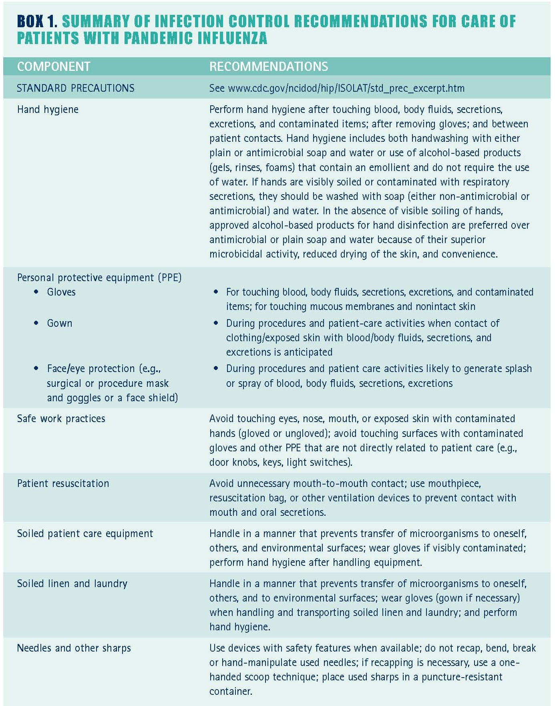
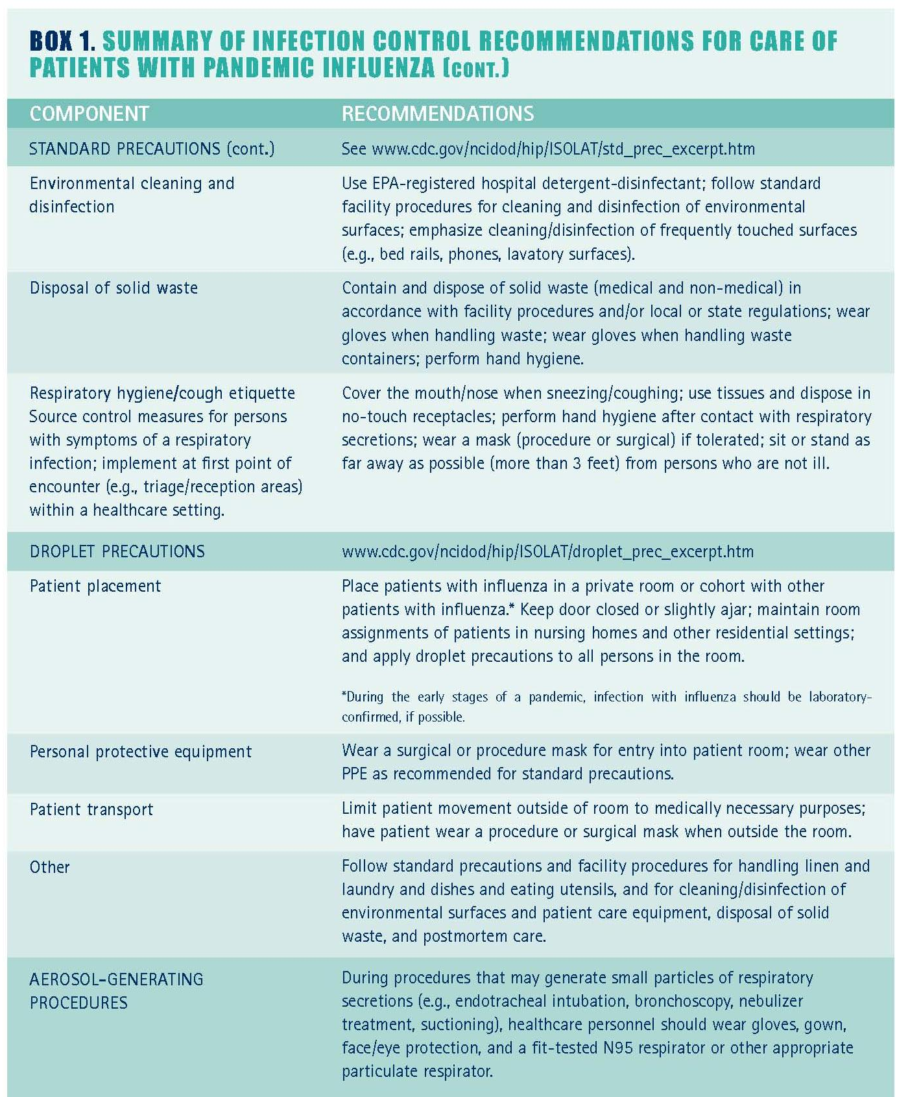
BOX 2. RESPIRATORY HYGIENE/COUGH ETIQUETTE

To contain respiratory secretions, all persons with signs and symptoms of a respiratory infection, regardless of presumed cause, should be instructed to:
• Cover the nose/mouth when coughing or sneezing.
• Use tissues to contain respiratory secretions.
• Dispose of tissues in the nearest waste receptacle after use.
• Perform hand hygiene after contact with respiratory secretions and contaminated objects/materials.

Healthcare facilities should ensure the availability of materials for adhering to respiratory hygiene/cough etiquette in waiting areas for patients and visitors:
• Provide tissues and no-touch receptacles for used tissue disposal.
• Provide conveniently located dispensers of alcohol-based hand rub.
• Provide soap and disposable towels for hand washing where sinks are available.

Masking and separation of persons with symptoms of respiratory infection
During periods of increased respiratory infection in the community, persons who are coughing should be offered either a procedure mask (i.e., with ear loops) or a surgical mask (i.e., with ties) to contain respiratory secretions. Coughing persons should be encouraged to sit as far away as possible (at least 3 feet) from others in common waiting areas. Some facilities may wish to institute this recommendation year-round.

Annex 4. Infection Control Summary Matrix

Service / Function:  Infection Control | Maine Inter-Pandemic Period: Awareness  Mitigation/ Preparedness  ME Level 0, I, II | Maine Pandemic Alert Period: Standby  Heightened Preparedness  ME Levels III, IV | Maine Pandemic Period: Activate Response Plan  Response  ME Levels V, IV | Maine Post Pandemic Recovery Period  Recovery  ME Levels VII
All Healthcare Settings
Hospitals  Detect persons entering facility who may have pan flu  Source control measures  Hospitalization of flu patients  Control nosocomial transmission | Post signs for respiratory hygiene/cough etiquette/hand hygiene. Ensure availability of materials in waiting areas. | Post visual alerts: Persons with respiratory symptoms should inform reception and practice cough etiquette. Designate separate waiting areas for patients with flu-like symptoms (at least 3 ft.)  Offer masks and spatial separation.  Obtain lab confirmation before cohorting patients, screen visitors and exclude symptomatic persons, family members should wear masks when accompanying patients with flu-like symptoms  Enhance surveillance | →Triage patients, discourage unnecessary visits. Set up separate triage area.  Limit admission to those with severe complications, place in single-patient room or cohort, lab testing likely to be limited so cohort based on symptoms, assign personnel to flu cohort units. Limit patient movement, if transport necessary, have patient wear mask and perform hand hygiene prior to leaving room. Limit visitors and instruct them to wear masks.  Cohort patients and staff. Restrict new admissions except for other flu patients. Restrict visitors, consider stopping elective surgeries
Nursing homes, other residential facilities  Prevent/delay virus entry into facility  Monitor patients for flu |  | Post visual alerts restricting entry by persons exposed to or with symptoms of influenza, screen visitors, provide phone number for info on control measures, screen all personnel, exclude symptomatic personnel until 24 hours after symptoms resolve  Increase surveillance, notify health department if case suspected, implement droplet precautions in symptomatic patient and roommates, cohort residents and staff on units with known or suspected cases | →  Limit movement within facility, temporarily close dining room and serve meals on units, cancel social/recreational activities
Prehospital care (emergency medical services) | Routine cleaning of the emergency vehicle and reusable patient care equipment | →Screen patients for symptoms, droplet precautions for symptomatic patients, place mask on patient to contain droplets, notify receiving facility of patient with possible influenza | →Consider masks for all patient transport, avoid aerosol-generating procedures unless medically necessary, optimize vehicle ventilation and when possible use vehicles with separate driver/patient compartments | →
Home healthcare services |  | Droplet precautions when entering home of person with flu-like illness | Consider contacting patients before home visit to assess influenza status, consider postponing nonessential services, assign providers not at increased risk of flu complications to care for flu patients
Outpatient medical offices  Detect persons who may have pan flu  Source control measures  Patient placement | Post signs promoting respiratory hygiene/cough etiquette. Ensure availability of materials in waiting areas | Post visual alerts at entrance. Persons with respiratory symptoms should inform reception and practice cough etiquette  Offer masks and spatial separation by symptomatic persons | Triage patients, discourage unnecessary visits  →  Designate separate waiting areas for symptomatic patients. Place symptomatic patients in evaluation room ASAP
Other ambulatory settings |  | Screen patients for symptoms, reschedule nonemergent appointments | →Cancel all nonemergent services
Care of influenza patients in the home |  |  | Physically separate flu patient from non-ill in home, patients should not leave home until 5 days after symptom onset (if leaving is necessary, wear mask), nonessential persons should not enter home/avoid close contact with patient, household members: closely monitor for symptoms development and contact medical care provider if symptoms occur, perform hand hygiene after patient contact, use masks, handle soiled laundry carefully and perform hand hygiene after
Care of influenza patients at alternative sites | Create all-hazard plans to identify designated alternative care sites |  | Provide care at alternative sites if healthcare resource capacity is reached, implement infection control principles used in healthcare settings

